Chapter 10, Solution 74.

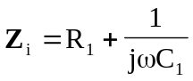, 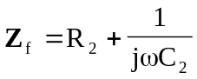

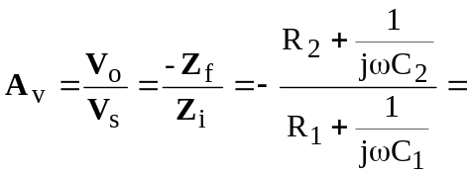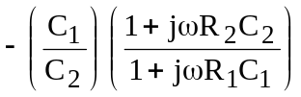

At 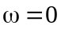, 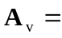–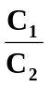

As , –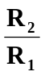

At 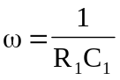, –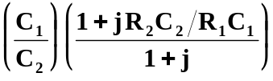

At  